### Solving analytical queries on RedShift Cluster

Here, you have to write the query used for solving the question and the screenshots of the table which is outputted after the query is run on the AWS RedShift Query editor UI.

1. **Top 10 ATMs where most transactions are in the ’inactive’ state**

<Query>

#query 1

select a.atm_number, a.atm_manufacturer, l.location, count(a.atm_number) as total_transaction_count, sum(case when atm_status = 'Inactive' then 1 else 0 end) as inactive_count, round((inactive_count * 100.00 / total_transaction_count), 4) as inactive_count_percent from etlschema.dim_atm a, etlschema.dim_location l, etlschema.fact_atm_trans f where f.atm_id = a.atm_id and f.weather_loc_id=l.location_id and f.atm_status = 'Inactive' group by a.atm_number, a.atm_manufacturer, l.location order by inactive_count DESC limit 10;

<Screenshot of the resultant table>

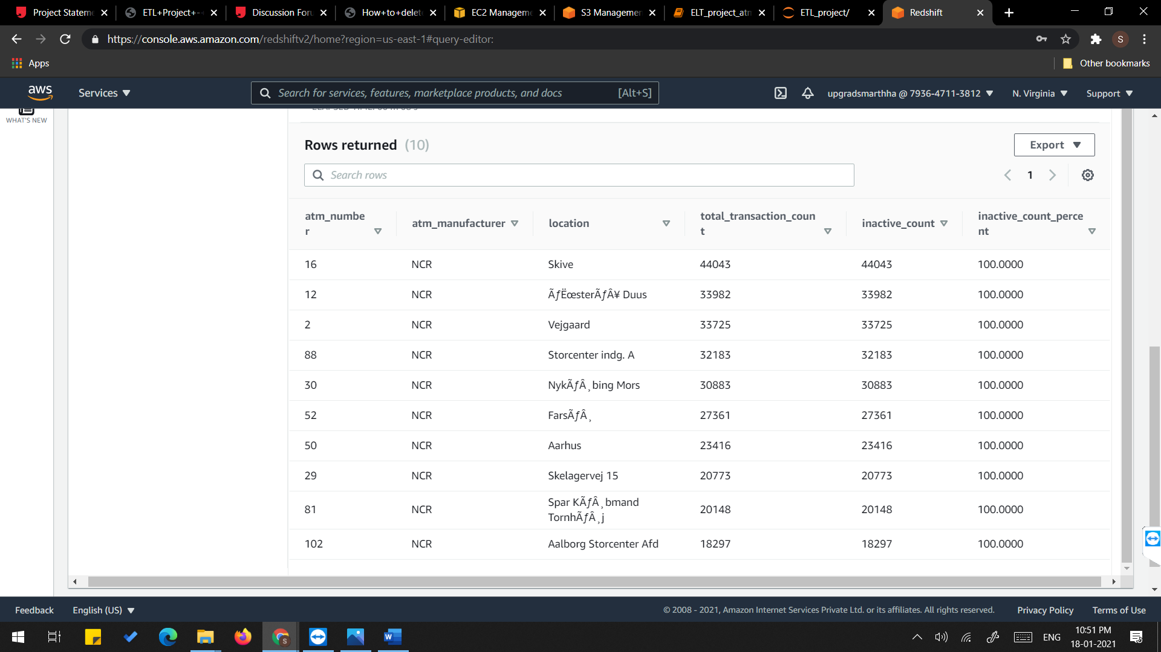

1. **Number of ATM failures corresponding to the different weather conditions recorded at the time of the transactions**

<Query>

#query 2

select weather_main, count(trans_id) as total_transaction_count, sum(case when atm_status = 'Inactive' then 1 else 0 end) as inactive_count, round((inactive_count * 100.00 / total_transaction_count), 4) as inactive_count_percent from etlschema.fact_atm_trans where ascii(weather_main) != 0 group by weather_main order by inactive_count_percent DESC;

<Screenshot of the resultant table>

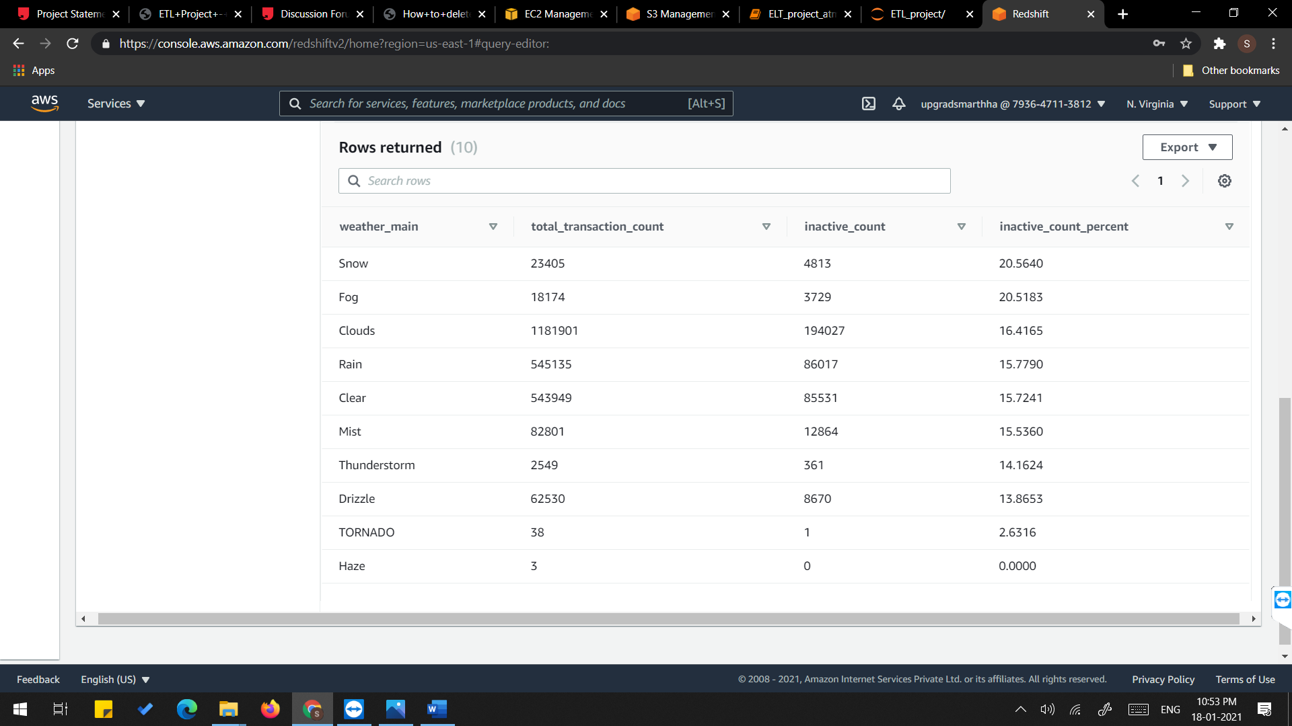

1. **Top 10 ATMs with the most number of transactions throughout the year**

<Query>

#query 3

select a.atm_number, a.atm_manufacturer, l.location, count(a.atm_number) as total_transaction_count from etlschema.dim_atm a, etlschema.dim_location l, etlschema.fact_atm_trans f where f.atm_id = a.atm_id and f.weather_loc_id=l.location_id group by a.atm_number, a.atm_manufacturer, l.location order by total_transaction_count DESC limit 10;

<Screenshot of the resultant table>

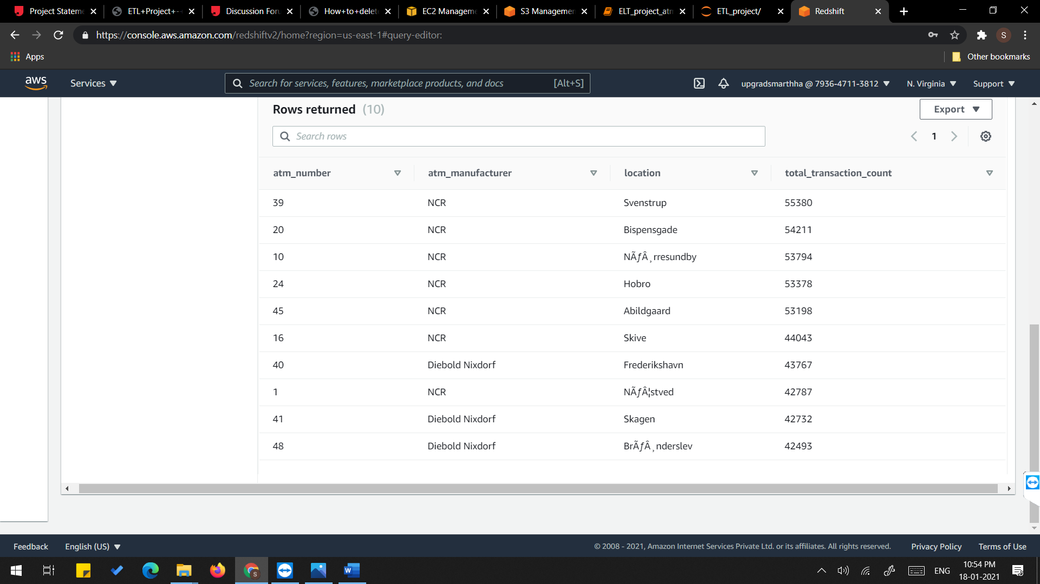

1. **Number of overall ATM transactions going inactive per month for each month**

<Query>

#query 4

select d.year,d.month,count(f.trans_id) as total_transaction_count,sum(case when f.atm_status = 'Inactive' then 1 else 0 end) as inactive_count, round((inactive_count * 100.00 / total_transaction_count), 4) as inactive_count_percent from etlschema.fact_atm_trans f,etlschema.dim_date d where f.date_id=d.date_id group by d.month,d.year order by d.month;

<Screenshot of the resultant table>

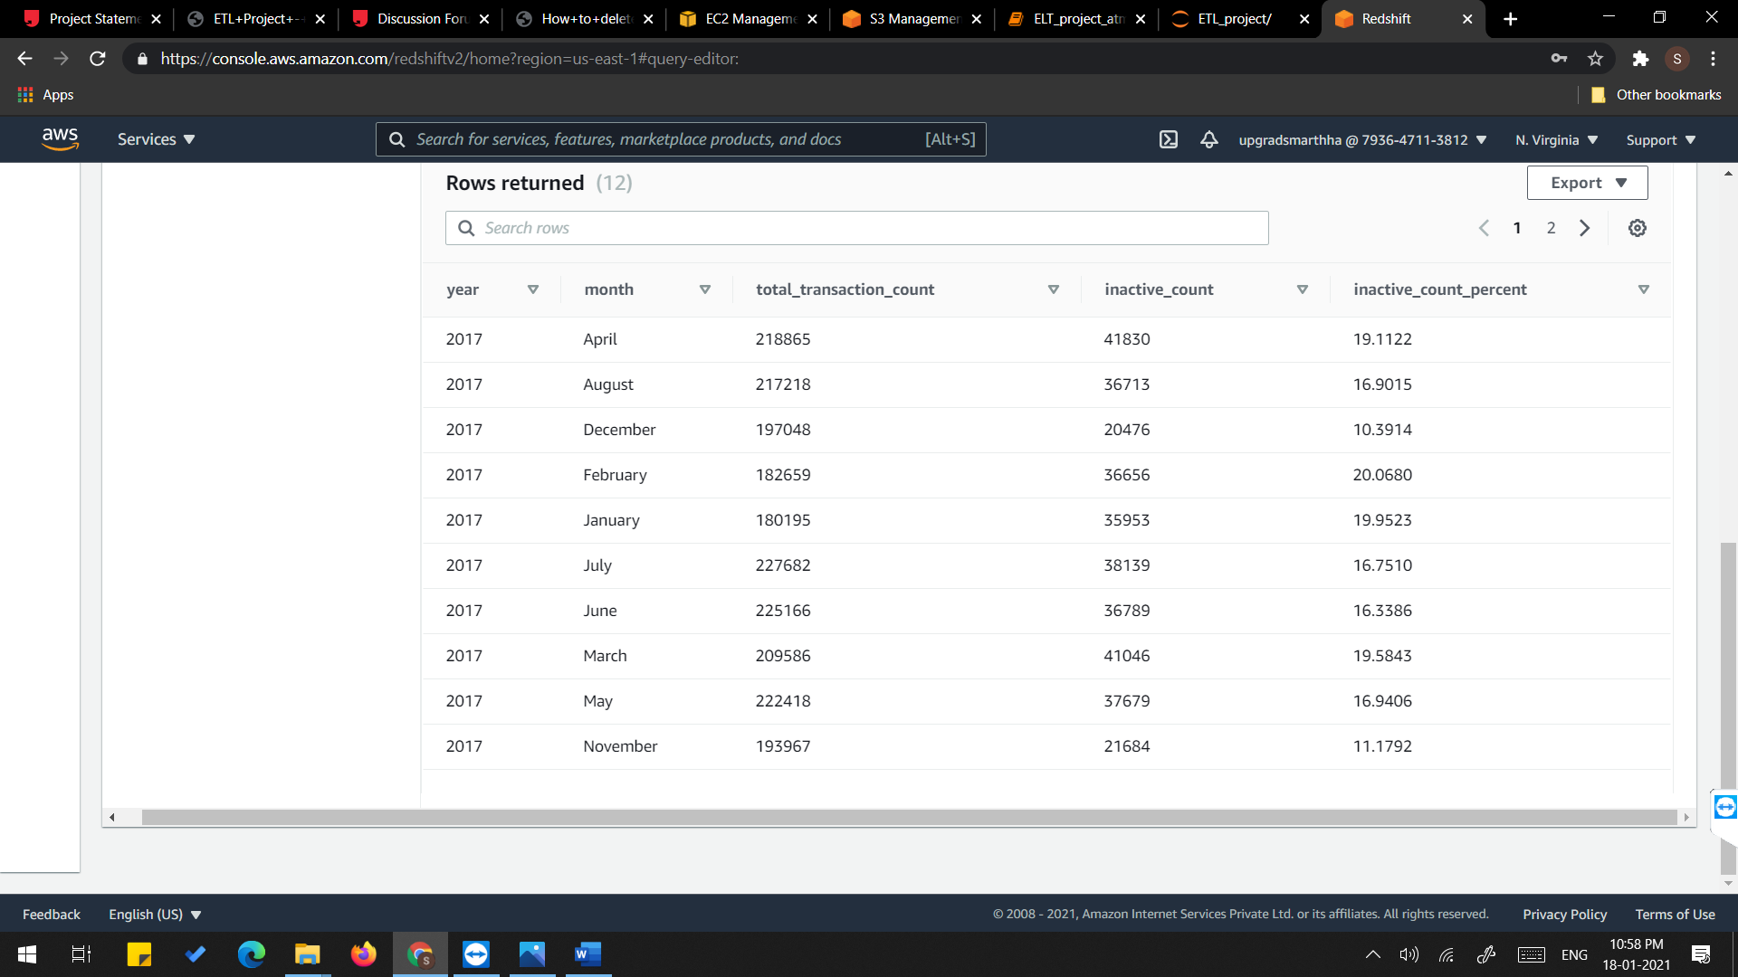

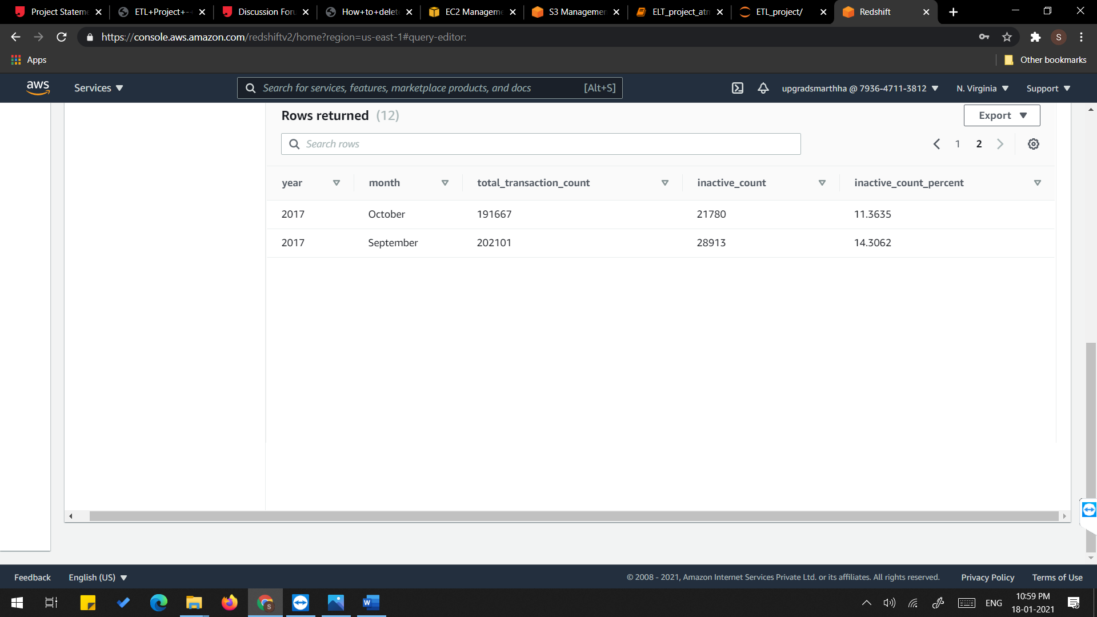

1. **Top 10 ATMs with the highest total withdrawn amount throughout the year**

<Query>

#query 5

select a.atm_number, a.atm_manufacturer, l.location, sum(f.transaction_amount) as total_transaction_amount from etlschema.dim_atm a, etlschema.dim_location l, etlschema.fact_atm_trans f where f.atm_id = a.atm_id and f.weather_loc_id=l.location_id group by a.atm_number, a.atm_manufacturer, l.location order by total_transaction_amount DESC limit 10;

<Screenshot of the resultant table>

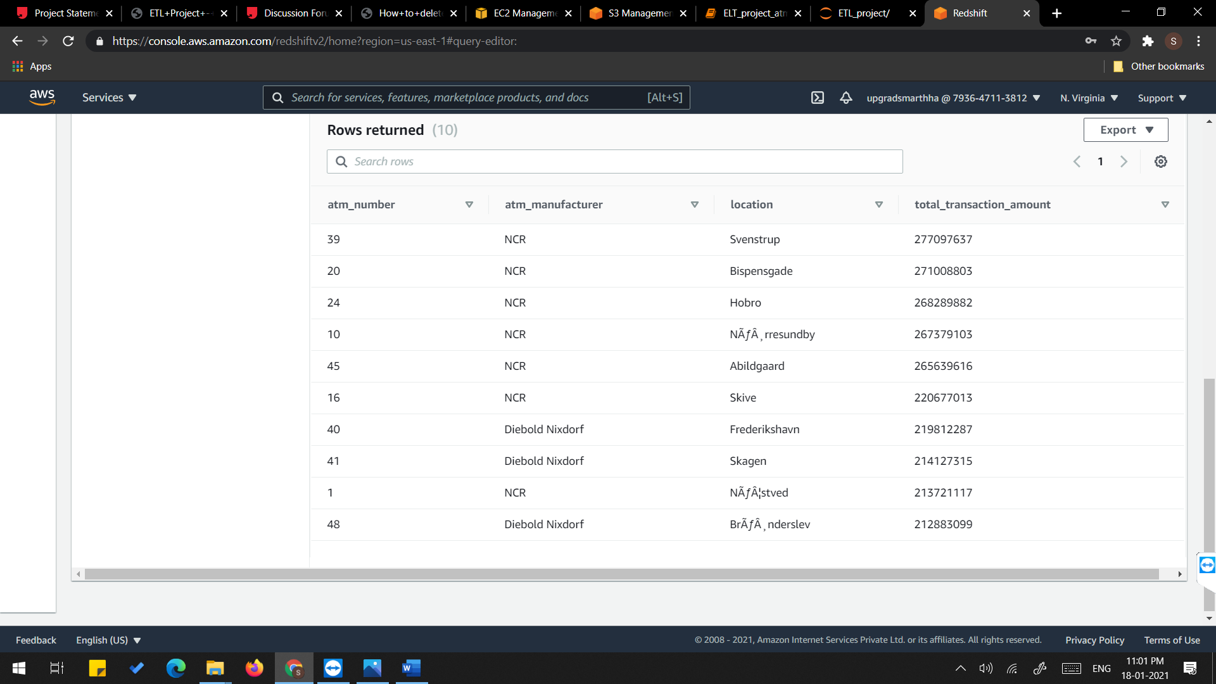

1. **Number of failed ATM transactions across various card types**

<Query>

#query 6

select c.card_type,count(f.trans_id) as total_transaction_count,sum(case when f.atm_status = 'Inactive' then 1 else 0 end) as inactive_count, round((inactive_count * 100.00 / total_transaction_count), 4) as inactive_count_percent from etlschema.fact_atm_trans f,etlschema.dim_card_type c where f.card_type_id=c.card_type_id group by c.card_type order by inactive_count_percent desc;

<Screenshot of the resultant table>

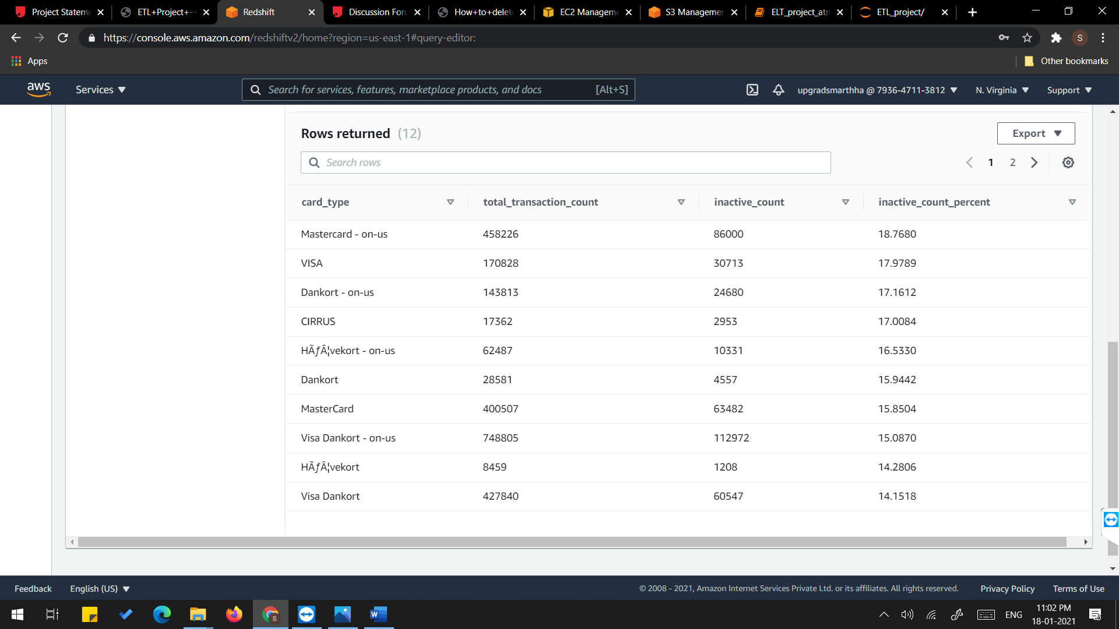

1. **Number of transactions happening on an ATM on weekdays and on weekends throughout the year. Order this by the ATM_number, ATM_manufacturer, location, weekend_flag and then total_transaction_count**

<Query>

# query 7

select a.atm_number, a.atm_manufacturer, l.location,case when d.weekday='Saturday' then 1 when d.weekday='Sunday' then 1 else 0 end as weekend_flag, count(a.atm_number) as total_transaction_count from etlschema.dim_atm a, etlschema.dim_location l, etlschema.fact_atm_trans f, etlschema.dim_date d where f.atm_id = a.atm_id and f.weather_loc_id=l.location_id and f.date_id=d.date_id group by a.atm_number, a.atm_manufacturer, l.location,weekend_flag order by a.atm_number limit 10;

<Screenshot of the resultant table>

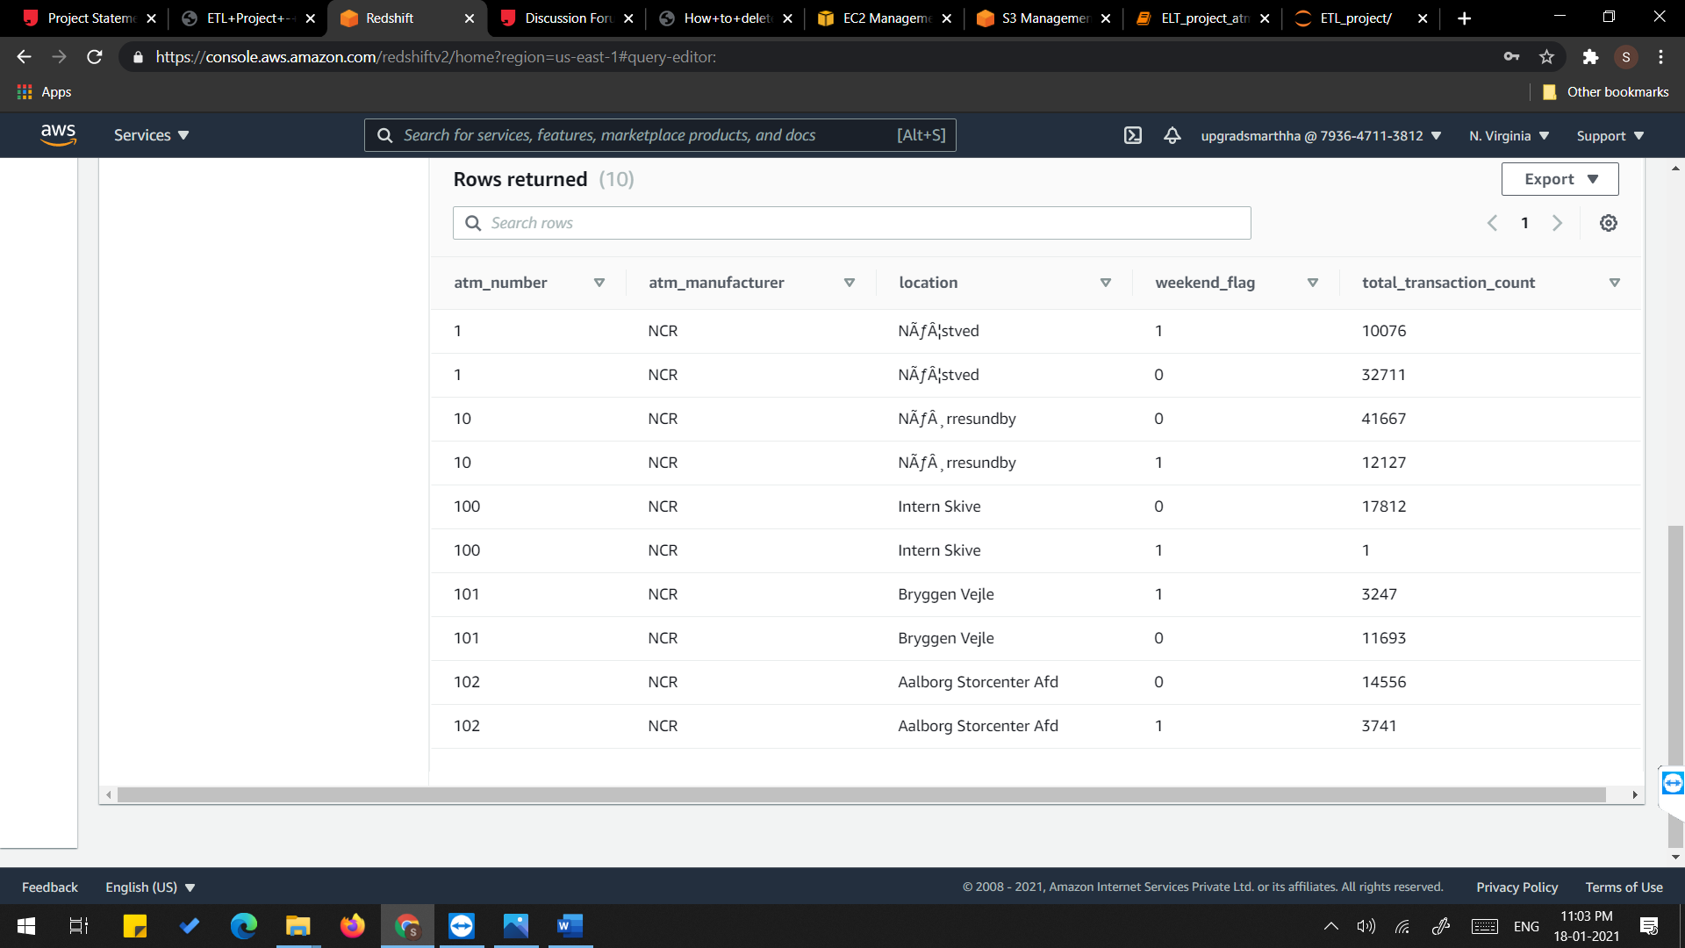

1. **Most active day in each ATMs from location "Vejgaard"**

<Query>

#query 8

select a.atm_number, a.atm_manufacturer, l.location,d.weekday, count(a.atm_number) as total_transaction_count from etlschema.dim_atm a, etlschema.dim_location l, etlschema.fact_atm_trans f, etlschema.dim_date d where f.atm_id = a.atm_id and f.weather_loc_id=l.location_id and f.date_id=d.date_id and l.location = 'Vejgaard' group by a.atm_number, a.atm_manufacturer, l.location, d.weekday order by d.weekday, total_transaction_count limit 2;

<Screenshot of the resultant table>

